Website showing CMR concept (includes calculation examples):

<http://www.dataq.com/blog/data-acquisition/calculate-common-mode-rejection-ratio/>

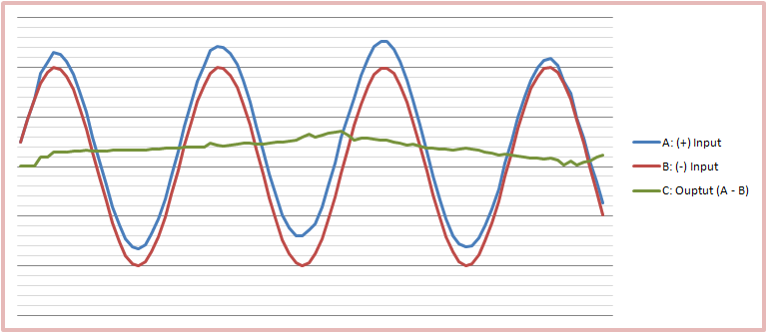

This is a pretty good explanation of common mode vs differential mode:

<http://www.radio-electronics.com/articles/circuit-design/resolving-emi-common-mode-normal-146>

Not a very concise explanation of common mode chokes:

<http://www.we-online.com/web/en/passive_components_custom_magnetics/blog_pbcm/blog_detail_electronics_in_action_61439.php>

* Common mode choke is where both line and neutral windings are wound on a single core